Detection of Diabetic Foot Ulcer using CNN
Monica M, Student , Naga Saranya K, Student
Mrs.V.Sathya Preiya, Assistant Professor,
Department of Computer Science and Engineering,
Panimalar Engineering College.

Abstract - Worldwide, 1 person in 11 has diabetes. Diabetic Foot Ulcers (DFU) is a major type of diabetes mellitus that, if not treated properly, can lead to serious side effects. It is usually the result of poor glycemic control, lower extremity neuropathy, peripheral vascular disease, or poor foot care. It is also one of the most common causes of foot osteomyelitis and amputation of the lower extremities. These sores are usually located in areas of the foot that experience repeated trauma and a feeling of pressure. Staphylococcus is a common infectious microorganism.
Current therapies in DFU therapy depend on patient and physician appointments, with important limitations such as the high costs involved in diagnosing, treating, and long-term care of DFU. We have compiled a database of foot images, containing DFU for different patients. Diabetic foot ulcers are more likely to cause serious problem than any other type of diabetes problem. Educating the patient about the problem and the need for appropriate medical care will reduce the risk of complications and compliance.
In this paper, we have suggested the use of traditional computer diagnostic features for foot ulcers among diabetic patients, representing a cost-effective, remote and simple healthcare solution. In this DFU classification problem, we examined two categories such as normal skin (healthy skin) and abnormal skin (DFU). Additionally, we have used Convolutional Neural Networks in the DFU category. We have developed a new design for the neural convolutional network, DFUNet, with the best feature extraction to highlight the characteristic difference between healthy skin and DFU. This works best for both machine learning and in-depth reading sections we have explored. Here we present the development of the novel with the most important DFUNet to detect the presence of DFUs accurately. This novel approach has the potential to bring about a paradigm shift in the care of diabetic feet.

Index Terms – Diabetic Foot Ulcer, Traditional convolution, Convolutional Neural Networks.

I. Introduction
With an estimated 34% of life-threatening foot diseases (DFU), it is one of the most common complications in diabetic patients. These wounds are associated with serious illness and death as they can lead to life-threatening complications, such as infections and amputations. DFU represents a complex inflectional disease that results in a number of influential factors including neuropathy, cardiovascular disease, and metabolic disorders, which can occur alone or in any concert. Because of the various pathological processes, DFU management requires a multimodal and interdisciplinary approach that must include (1) prevention, (2) the identification of various processes that contribute to its formation, and (3) the promotion of wound healing. The current pillar of DFU management includes prevention with standard wound care principles. Therefore, there is a need for new therapies targeted at all aspects of DFU wound care, which include wound prevention and promoting wound healing in its formation. Combined therapies are often indicated when DFU has failed SOC and may be a new goal at DFU care level. However, many of these therapies are expensive, and little is known about their true clinical effectiveness. In this review, we aim to re-evaluate the extent to which DFU care requires a comprehensive approach, which includes treatment targeted at a variety of DFU etiologies and promotes wound healing. We are also reviewing the latest trends in DFU management.
Prevention begins with proper testing in diabetic patients. The American Diabetes Association (ADA) recommends testing for neuropathy every year, starting with the diagnosis of type 2 diabetes and 5 years after the diagnosis of type 1 diabetes. The neuropathy test should include a careful history, which confirms that you inquire about the symptoms of paresthesia, burning, and diminished or absent sensation. Each patient should also undergo a neurological test using a 10-g monofilament test to detect loss of hearing sensitivity and to identify a person's risk of injury and amputation. Additional tests may include temperature sensing and pinprick as well as vibration tests. Suitable footwear includes shoes made of forgiving materials (e.g., leather) and that can carry foot deformities and edema. Proper footwear can reduce pressure points; to reduce shock, shear stress, and the formation of calluses. More importantly, it has been shown to block DFU. Improperly worn shoes, those that are too old, or that cause itching, erythema, blisters, or calluses should be avoided. As there are many basic factors that influence DFU, changing risk factors is also an important factor in prevention. Strict glycemic control has been shown to delay or prevent diabetic neuropathy. However, strict glucose control in patients with DFU may have little effect on ischemia; therefore patients should try to reverse other risk factors for ischemia, such as atherosclerosis. These may include severe ischemic adjustment, weight loss, smoking cessation, and reduced alcohol consumption. Patients may also consider leg height and stock pressure to reduce edema in the event of venous insufficiency. Finally, calluses are a major risk factor for ulcers, as they increase plant stress, leading to tissue rupture. Therefore, regular removal of callus is recommended. Although it is well known that adequate nutrition is important in wound healing and that metabolic imbalances contribute to the development of DFU, the role of nutrition and supplementation in DFU prevention is unclear.
Malnutrition is common in DFU patients, but there is little strong evidence that better nutrition or support will improve wound healing or prevent early DFU. Most studies on nutrition and DFUs are not Randomized Controlled Trials (RCTs), they usually have a variety of variable effects, and do not provide clear longitudinal and clinical data. For example, recent RCTs studying the effect of vitamin D, vitamin E, and magnesium supplementation on DFU found a reduced lesion size, but did not actually report complete wound healing. These may be some of the reasons why the ADA does not directly promote nutritional support in the management of diabetic foot care..

2. LITERATURE SURVEY

[1] Matilde Monteiro-Soares, Edward J. Boyko et.al “Diabetic foot ulcer classifications: A critical review” Wiley Online Library 16 March 2020

The purpose of this study was to evaluate published systems for diabetic foot ulcers (DFUs) to determine which ones should be recommended for a given clinical purpose. The published sections were to be verified for more than 75% of people with diabetes and foot ulcers. Each study was evaluated for internal and external validity and reliability. Eight key factors associated with healing failure were identified in a large series of clinics and each classification was characterized by a number of key factors. The categories were then organized according to their proposed purpose into one or more groups: (a) collaboration between care professionals, (b) predicting the clinical outcome of individual lesions, (c) assisting in clinical management decisions in each case, and (c) assisting in clinical management decisions each, and () d) a study comparing the results of indifferent people. Clinical outcomes were not the same but included life without ulcers, wound healing, hospitalization, amputation, death, and costs. Despite the limitations, there has been sufficient evidence to recommend the use of certain categories of indicators listed above.

[2] Mayland Chang and Trung T. Nguyen “Strategy for Treatment of Infected Diabetic Foot Ulcers” 2021 American Chemical Society

Diabetic foot ulcers (DFUs) are chronic ulcers in about 30% of diabetic patients. In DFUs, the normal wound healing process involving inflammation, angiogenesis, and rearrangement of the extracellular matrix (ECM) is disrupted and stopped. Upon injury, neutrophils and monocytes reach the wound and release matrix metalloproteinase (MMP) -8 and active oxygen species (ROS). ROS activates the nuclear factor kappa beta (NF-κB), which regulates MMP-9. Monocytes become macrophages, producing tumor growth factor (TGF) -β1 and vascular endothelial growth factor (VEGF) for angiogenesis, leading to ECM regeneration. MMP-9 breaks down lamin for keratinocyte to migrate. MMP-8 has benefits in ECM regeneration and wound healing. In DFUs, uncontrolled MMP-9 is dangerous, destroys ECM and prevents the wound from healing. DFUs are highly contagious, many of which contain biofilm-resistant viruses. The infection increases the healing time of the wound and the chances of amputation. In addition to the use of antibiotics, amputation occurs in 24.5% of patients with DFU.

[3] Moi Hoon Yap a , Ryo Hachiuma et.al “Deep learning in diabetic foot ulcers detection: A comprehensive evaluation” Computers in Biology and Medicine (2021)

This paper summarizes the results of DFUC2020 by making comparisons between in-depth learning-based algorithms proposed by the winning teams: Quick R - CNN, three versions of Faster R - CNN and the integration method; YOLOv3; YOLOv5; Effective Det; and the new Cascade Attention network. For each in-depth learning method, they provide a detailed description of the model structures, training parameter settings and additional categories that include pre-processing, data development and post-processing. We provide a complete overview of each method. All methods require a data addition phase to increase the number of images available for training and the processing stage after extracting false points. Excellent performance was obtained from Deformable Convolution, a variant of Faster R - CNN, with an average accuracy (MAP) of 0.6340 and a F1-Score of 0.6834. Finally, we show that integration based on in-depth learning methods can improve F1-Score but not MAP.

[4] Danielle Dixon, Michael Edmonds et.al “Managing Diabetic Foot Ulcers: Pharmacotherapy for Wound Healing” Springer Nature Switzerland AG 2020

This article highlights experiments, and describes the current medical management of diabetic foot ulcers and the progress made in wound treatment to date. Provides an overview of current and current therapeutic and systemic therapies for future use in the management of diabetic foot disease. For each treatment, the proposed methods and available evidence to support their clinical use are presented. Growth factors, bio-engineered tissue, stem cell therapy, gene therapy and peptide therapy also have supporting evidence for the treatment of foot ulcers in diabetes. Non-supportive contaminants may be helpful if effective expulsion is not possible, and immune modulators may be helpful in their antimicrobial effects, but strong data is still needed to strengthen the case for normal use. Reviews do not include antimicrobials as their main role is to prevent penetration and not in wound healing. Advances in nanotechnology have made it possible to extend the bioavailability of targeted molecules to the wound site, using glass / hydrogel nanoparticles, polyethylene glycol and hyaluronic acid. Looking ahead, newborn treatments, which include heavy loads, local delivery of less disruptive RNA and ultimately hydrogels include bioactive agents or cells that may provide potential pharmacies in the future.

[5] Dragos Serban, MD, PhD1, Nikolaos Papanas, MD, PhD et.al “Diabetic Retinopathy in Patients With Diabetic Foot Ulcer: A Systematic Review” The International Journal of Lower Extremity Wounds 2020

This review discusses the evidence for diabetesic retinopathy (DR) in patients with diabetesic foot ulceration (DFU). Official literature reviews are conducted at PubMed, Medline, Springer Nature, and Scopus, in accordance with PRISMA guidelines, using the following terms, individually or collectively: "diabetes" or "diabetes" or "DFU" and "Diabetes and Diabetes Retinopathy. Initial search revealed 648 articles published between 1975 and 2020. After applying the terms of publication and posting, a total of 9 articles were analyzed, examining the relationship between DR and In all cases, DR and proliferative retinopathy of diabetes were significantly higher before DFU, although the frequency of DR showed significant fluctuations (22.5% to 60.6%) and increased frequency of DR and proliferative diabetesic retinopathy. progression of DR to DFU incontinence, which is possible Therefore, patients with DFU should be monitored by an optometrist, and those with DR should be referred to a specialist immediately. t diabetic foot clinic.

[6] Morica M. Tran and Melanie N. Haley “Does exercise improve healing of diabetic foot ulcers? A systematic review” Journal of Foot and Ankle Research (2021)

This systematic review found that there is ample evidence to fully support weightless exercise as an intervention to improve wound healing for diabetic foot. Regardless, the results show a degree of reduction in wound size and there were no adverse effects of participant intervention. In view of the potential benefits of physical activity in a patient's health and well-being, weightless exercise should be encouraged as part of a diabetic foot treatment management program. Further research is needed to better understand the relationship between exercise and the healing of sores on diabetic foot.

3.1. EXISTING SYSTEM

The proliferation of information and communication technologies poses both challenges and opportunities regarding the development of modern health care systems.
There are many telemedicine programs under construction right now
a) improve current health care systems and reduce the cost of medical facilities;
b) improve access to medical facilities which is a continuous remote examination of patients with the help of communication equipment;
c) provide automated solutions to address the shortage of medical professionals in these chronic diseases.
Over the years, researchers and doctors have developed important telemedicine programs to monitor diabetes. However, there are very few smart programs designed for diabetic foot tests that can be broken down into non-automated and automated telemedicine programs.
Nowadays, a smart-sized mobile phone with an advanced mobile app has the power of a personal computer capable of capturing and sending high-resolution images and audio and video communication with the help of advanced mobile internet such as 4G. In the non-automatic category, conventional telemedicine systems based on these devices are usually set up remotely for patient monitoring. While these programs provide promising results, there is an urgent need for smart systems that can automatically detect various DFU infections from a distance.

3.2. PROPOSED SYSTEM

Compared to traditional features, deep learning, especially the convolutional neural networks, have been used to distinguish between healthy foot skin and diabetic skin lesions. In order to improve the release of key features of DFU segregation, we propose a Convolutional Neural Network that uses multiple layers of convolutions and pooling layers to extract multiple features from the same input. Healthy skin tends to have a smoother texture and DFU has many different features including large edges, strong color changes and a quick transition between healthy skin around it. This proposed program classifies images of diabetesic foot ulcers based on the features of the included image. The major challenges involved in this segregation process are the following:
1) Great time for professional collection and labeling of DFU foot images.
2) Higher differences between normal and abnormal skin lesions and intra class variations depending on DFU classification, light conditions and patient race.
In this work, we have explored a number of Conventional Machine Learning (CML) and Convolutional Neural Networks (CNNs) methods to distinguish wounds from non-lesions in order to improve the release of a feature that can clearly detect changes in skin texture and color, wound and healthy skin with the help of parallel convolution layers that remove many of the features of the same input and work faster with the help of better and more precise and sensitivity than other popular systems.

Benefits of the Proposed System
• CNN's biggest advantage compared to its predecessor is that it acquires key features without being monitored.
• CNN also works well with efficiency.
• Uses special convolution and integration functions and performs parameter sharing. This allows CNN models to work on any device, making them attractive worldwide.

3.3. FEASIBILITY STUDY

The feasibility of a project is assessed at this stage and the business proposal is made with the most common project plan and specific cost estimates. In order to analyze the feasibility, some understanding of the major system requirements is essential.
The three key factors involved in possible analysis are:
• Economic feasibility
• Technical feasibility
• Operational Possibility.

ECONOMIC FEASIBILITY
This study is designed to assess the economic impact of a project. The amount of fund that a company can invest in research and program development is limited. Expenses must have a reason. The main purpose of this project is to provide an affordable solution for people suffering from foot ulcers. In this way the plan is further developed within the budget. It is possible that even poor people can make good use of it. Thus the system improved and within budget and this was achieved because most of the technology used is available for free. Only custom-made products should be purchased.

TECHNICAL FEASIBILITY
Any upgraded system should not have a high demand for available technical resources. This will lead to higher demands on the consumer. This is associated with the complexity of system technology. For this project, we use Convolution Neural Networks which provides a high level of success in diagnosing various diseases. It takes an image as inserting and passing convolutions to remove unwanted features and remove many important features from the image.

OPERATIONAL FEASIBILITY
This includes the process of training the user to use the system correctly. The user should not feel threatened by the system, but should accept it as a necessity. This system will be easier to use and will produce a higher level of accuracy compared to the existing system.

3.4. HARDWARE ENVIRONMENT
Device : Laptop / Desktop
Processor : Pentium Dual Core 2.00 GHZ
Mouse : Wired or Wireless
Hard Disk : 120GB
RAM : 2 GB (Minimum)
Keyboard : 110 Keys enhanced

3.5. SOFTWARE ENVIRONMENT

Operating System : Windows 7 and more
IDE : Anaconda
Language : Python

4. SYSTEM DESIGN

4.1. ER DIAGRAM

The ER represents Entity Relationships Diagrams. The Entity Relationship Diagram (ERD) is a visual representation of the various organizations within the system and how they relate to each other. They are widely used to design database relationships. Businesses in the schema turn into tables, attributes and modify the schema of the website. These are used during the planning stages of software projects.
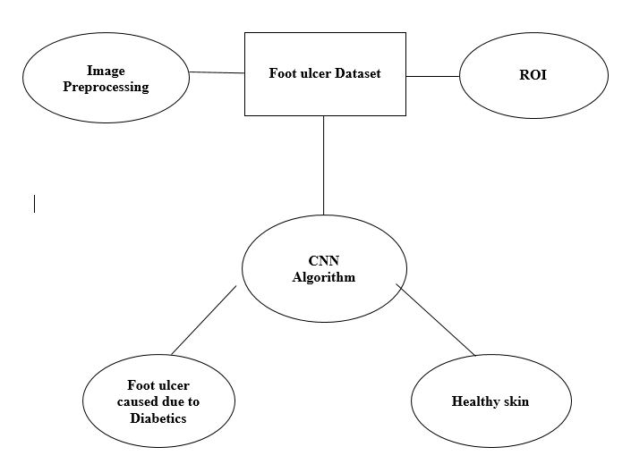Figure.4.1.1. ER Diagram for Diabetic Foot Ulcer

4.2. UML DIAGRAMS
Unified Model Language [UML] is a common modeling language. The main purpose of the UML is to explain the general way in which the system is designed. It is exactly the same as the plans/blueprints used in other engineering fields.

4.2.1. USE CASE DIAGRAMS

Use case diagrams are a set of use case, actors, and their relationships. It is used to describe the relationship between performance and their internal / external controls. These controls are known as actors.

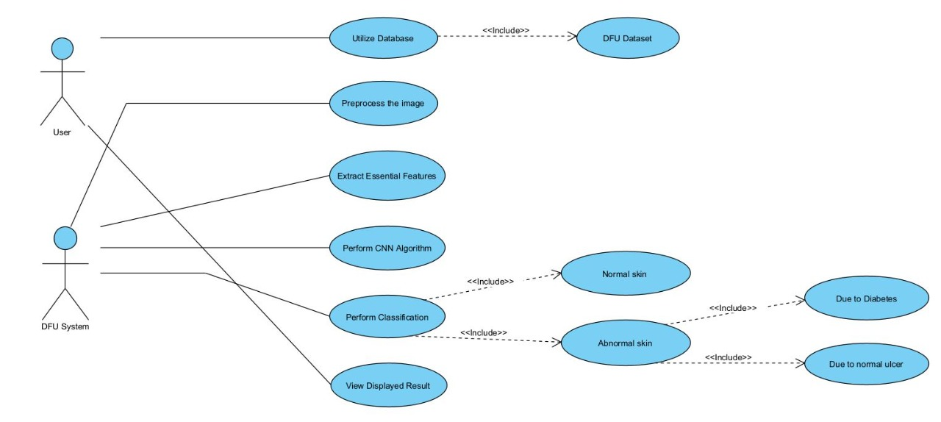

Figure.4.2.1.1. Use case Diagram for Diabetic Foot Ulcer

4.2.2. ACTIVITY DIAGRAM

An Activity diagram describes the flow of control in a system. Contains activities and links. The flow can be sequentially, parallel, or branches. Tasks are nothing but program functions. Activity diagrams are used to visualize the movement of controls in a system.
The main purpose of Activity Diagram is to show the business and software processes as a progression of actions. These actions can be carried out by people, software components or computers.
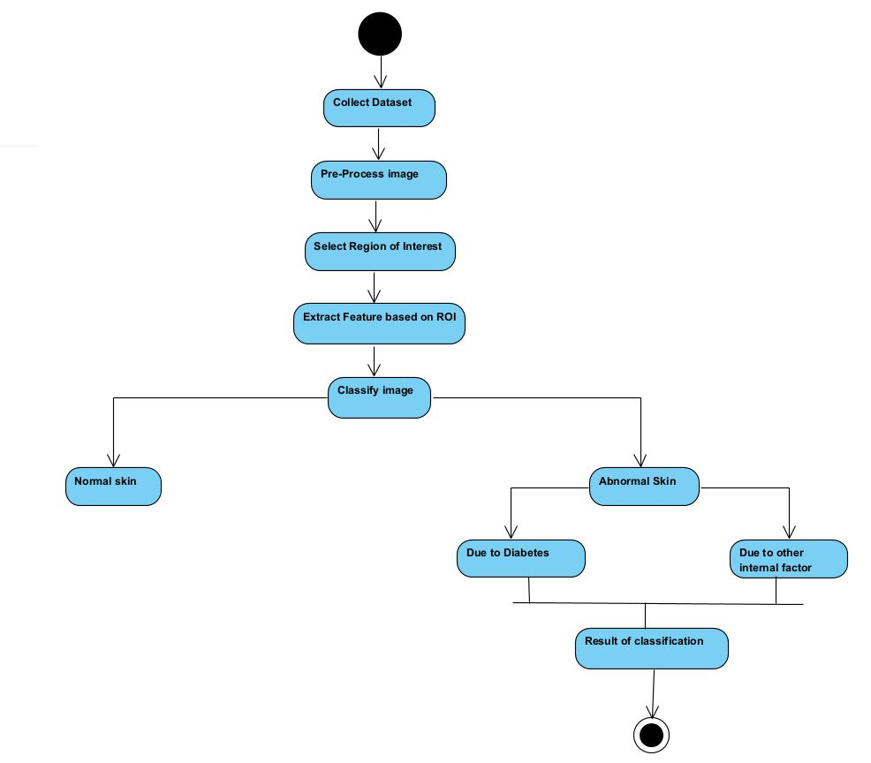
Figure.4.2.2.1. Activity Diagram for Diabetic Foot Ulcer

4.2.3. SEQUENCE DIAGRAM

Sequential diagram is a diagram of interaction. From the word, it is clear that the diagrams are based on the sequence of events, that is, the sequence of messages that flow from one object to another. Since visualizing the interactions in a system can be a cumbersome task, we use sequence diagram to capture the various features and aspects of interaction in a system.
Here the sequence of events that are happening between the objects is depicted in a sequential manner (i.e) a sequence of messages are being passed between the objects.

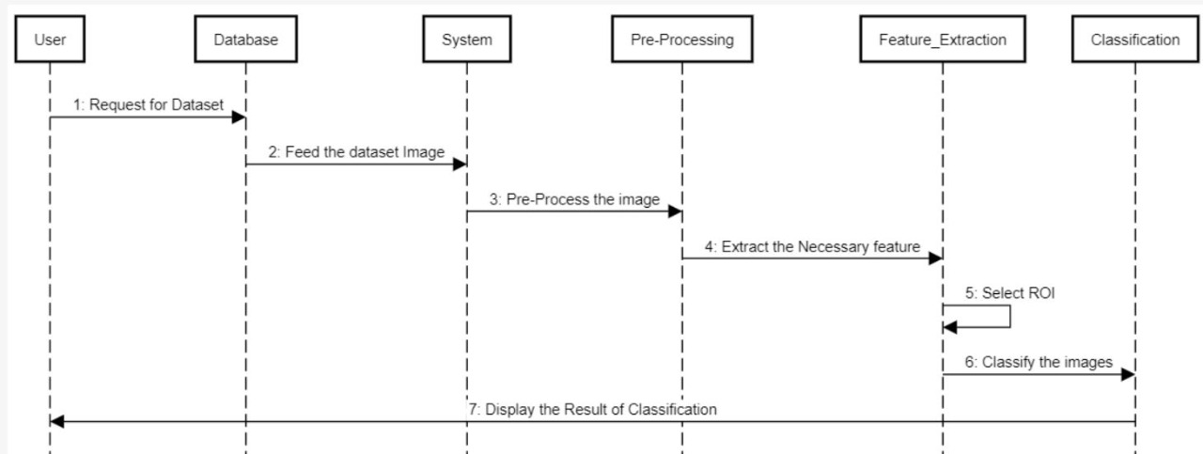

Figure.4.2.3.1. Sequence Diagram for Diabetic Foot Ulcer

4.3. ARCHITECTURE DIAGRAM
Architectural diagram is a system diagram used to extract the entire structure of a software system and the relationships, boundaries, and boundaries between components. It is a visual representation of the visual implementation of software system components.
It provides an advanced view of the process or program, making it easy to get a clear idea of ​​the system.
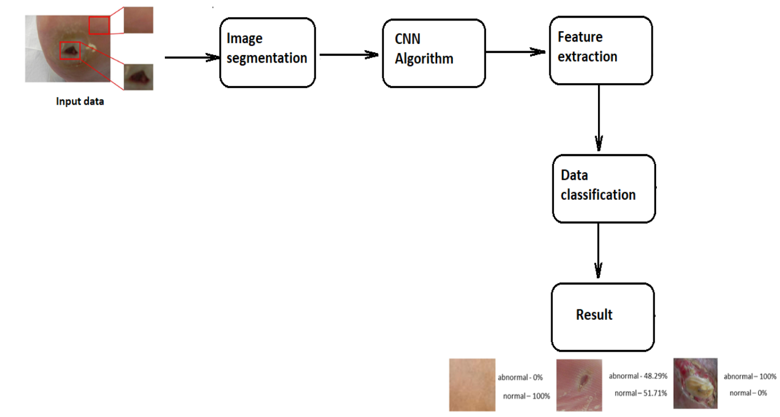

Figure.4.3.1. Architecture Diagram for Diabetic Foot Ulcer

5. SYSTEM ARCHITECTURE

5.1. MODULES

This system consists of the following modules:
• Dataset Collection
• Image Pre-Processing
• Feature Extraction
• Region of Interest
• Classification

A) Dataset Collection
A collection of high-quality medical metaphors known as the catalog is a necessary tool for checking compliance and comparing medical image processing algorithms. The foot ulcer site represents general and diabetic images that are touched by the patient's footprints and verified professionally.

B) Image Pre-Processing
Pre-image processing is a step taken to format images before they are used in training and interpreting models. This includes, but is not limited to, changing size, shape, and color correction. It also includes many techniques as part of gravy, noise removal, and enhanced brightness.

C) Feature Extraction
Features Image background consists of a lot of information, some of which is the only information that can be used to differentiate between different situations. Most of the information in the image should be converted to a reduced representation set called the "Exit Feature". An image has many elements such as texture, color, and shape. These features can be used as a small representation of useful information in the image that can be used to distinguish between different situations. In this study, a variety of textures and colors were used to identify the foot wound in the images.

D) Region of Interest
It is a version of the "relevant measure range". The term is used to refer to the appropriate stage of the equation curve. This area can be considered statistically best. Based on the area of ​​interest (ROI) you can calculate, for example, maximum value, scale and width range, and the area below the curve. Recorded measurement curves can be, for example, calculated values ​​(number per unit of time) registered in appearance, time or near trajectory.
About the region of interest (ROI) as two or three dimensions are common in computer-controlled image processing and photography processes. In the worst cases, for a long time there is even a four-sided view. The region of interest is often used for medical purposes, especially in nuclear medicine. In this case the ROIs are multidimensional.
In the default ROI test software it supports the user slightly to find out which area is questionable. The user only specifies the specified category that goes on and is completed by the testing software. With this type of acquisition, the user can set up approximately where the testing software should work.
The region of interest (ROI) is the part of the image that you want to filter or work on in some way. You can represent ROI as a picture of a binary mask. In mask image, ROI pixels are set to 1 and external ROI pixels are set to 0. The toolbox offers a few options for specifying ROI and creating a binary mask. The toolbox supports a set of tools that you can use to create multi-sided ROIs, such as circles, ellipses, polygons, rectangles, and hand-drawn shapes. Once you have created the material, you can adjust its shape, its shape, its appearance and its behavior.

E) Classification
Image separation is done when a computer can analyze an image and identify the 'category' of the image that falls under it. According to the released version, the system diagnoses foot ulcers caused by diabetics or other diseases.

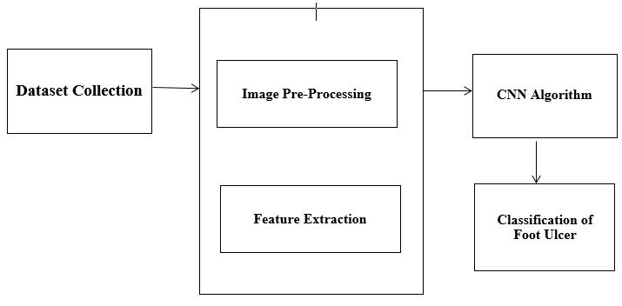
Figure.5.1.1 System Design for Diabetic Foot Ulcer

5.2. ALGORITHM

In order to improve the extracted features of Diabetic Foot Disease Separation, we have proposed a system that uses Convolution Neural Network Architecture (i.e.) a deep and consistent flexibility layer. Initially the system uses traditional convolution layers that are useless except for one convolution filter followed by the corresponding convolution layers to extract a large number of elements from the mage given as input. Identifying changes in healthy skin is a clear problem to identify with a computer as harmful skin lesions, so DFUNet is built on the modification in detecting discriminatory features in the study.
Healthy skin tends to show a smoother texture and DFU has many different features including large edges, dynamic dynamics or color changes and quick changes in the area of ​​healthy skin and the wound itself.
Here each image is trained with 30 Epoch to extract precise features from the given images.
1) Input Data:
DFU training and image stabilization features such as 256 × 256 pads from areas with foot ulcers for diabetes and healthy skin. Performing this step also ensures that the image size of the raw material is reduced before moving on to the following layers.
2) Similar Changes:
The traditional conversion categories use only one popular type of convolution filter from 1 × 1 to 5 × 5 input data. Each filter convolution provides a different feature for the same input. The concept of using a compatible convolution layer states that it is basically a combination of a convolution filter that allows for the removal of a multi-level element and over-covering of clusters by adding the same.
Three sizes of convolution characters are used for the same DFUNet variables in total: 5 × 5, 3 × 3 and 1 × 1. These are processed according to each other and finally integrated. Each convolution provides additional discriminatory power. Low performance is present in healthy skin samples due to the absence of skin deformities. High performance is present on the skin of sores on diabetic feet due to abnormal skin. Each convolution layer uses a Rectified Linear Unit (ReLU) defined as
f (x) = maximum (0, x)
where the work holds a zero limit. As we use ReLU for each convolution, which includes unlimited activation, so we use local response normalization (LRN) to initiate this function after each combination of convolution layers. To avoid the problem of inequality that occurs on many CNN channels, we use,
Let (i / x, y) be the source kernel in place (x, y) and b (i / x, y) be the standard output (x, y).
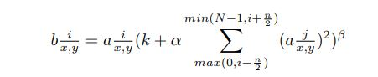

where N is the no.of.kernels and α,β,k,n are parameters.
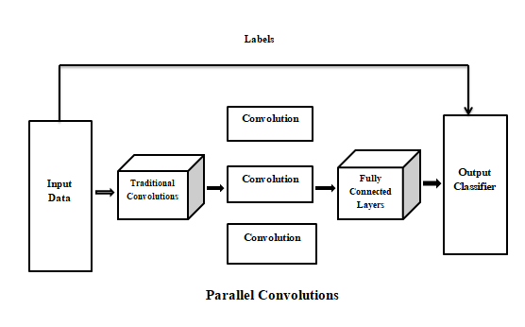
Figure.5.2.1. An overview of Convolutional Architecture for Diabetic Foot Ulcer

3) Fully Connected Layer and Output Classifier :
There are two output classes for the DFU. They are the healthy and the diabetic foot ulcer skin. It is formed by the Max polling layer followed by 2 fully connected layers. Same as the Convolution Layer, the Pooling layer is bound to reduce the local size of the Extracted Feature. This is to reduce the calculation power required to process data by reducing the size. There are two types of pooling : 1) Average Pooling 2) Max Pooling. In Max Pooling we find the maximum number of pixels in the part of the image covered by the kernel. Max Pooling also acts as a Noise Suppressant. It eliminates noise activation completely and performs noise removal and reduction in size. On the other hand, Average Pooling returns the values of all ​​part of the image covered by the Kernel. So we can say that Max Pooling does much better than Average Pooling
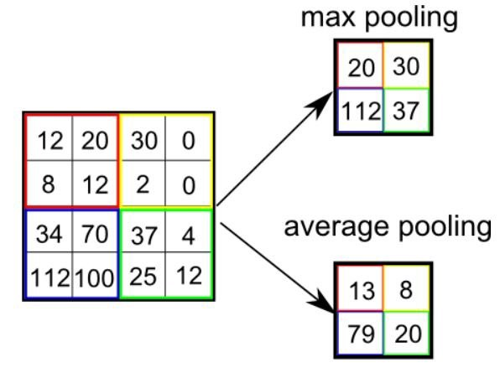
Figure.5.2.2. Pooling Example for Diabetic Foot Ulcer

6. SYSTEM TESTING

The purpose of the testing is to find errors. Testing is the process of trying to identify every possible flaw or weakness in the product. Provides a way to test the performance of parts, sub-assemblies, assemblies and / or finished product. It is a software application to ensure that the Software system meets its requirements and expectations of users and does not fail in an unacceptable way. There are different types of tests. Each type of test meets a specific test requirement.

6.1. TEST CASES AND RESULTS

Field testing will be performed manually and functional tests will be written in detail.

Test Objectives :
• All field entries must work properly.
• Pages must be activated from the identified link.
• The entry screen, messages and responses must not be delayed.

Features To Be Tested :
• Verify that the entries are of the correct format
• No duplicate entries should be allowed
• All links should take the user to the correct page.

Result :
All the test cases mentioned above passed successfully. No defects encountered.

7.CONCLUSION AND FUTURE ENHANCEMENTS

In this work, we trained various differentiators based on conventional machine learning algorithms, CNN and developed a CNN structure, DFUNet, focused on diabetic foot ulcers. With high performance standards in isolation, DFUNet allows automatic DFU detection of images of sores on the feet and facilitates testing and treatment of the new DFU method. This work lays down the technical foundations that could transform the simultaneous diagnosis of all ulcerative foot ulcers and that led to a paradigm shift in the clinical care of diabetic foot.
This work has created a foundation for future benefits that include: 1) the development of an automatic annotation that can be automatically defined and categorized without the assistance of nurses; 2) improve the detection of spontaneous lesions and the detection and isolation with the help of these separators; 3) develop easy-to-use software tools that include mobile wound detection applications. As DFUNet is effective in differentiating DFU, this proposed framework can be useful in isolating other skin lesions such as ulcers, infections such as pneumonia or shingles, other skin lesions such as moles and freckles, spots and acne.

7.APPENDICES

- Open the command prompt to access the folder.
- Type idle to open the File and to get the URL for the web application.
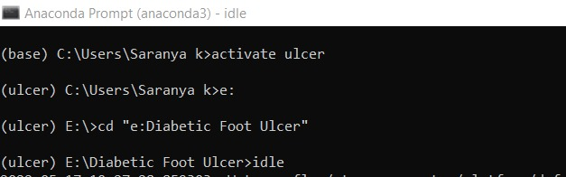
Figure.7.1. Anaconda Prompt

- Open the file that contains the code in the idle and Run the module.
- Once it is done, the idle displays an URL which must be copied and pasted to the browser to access the web application.
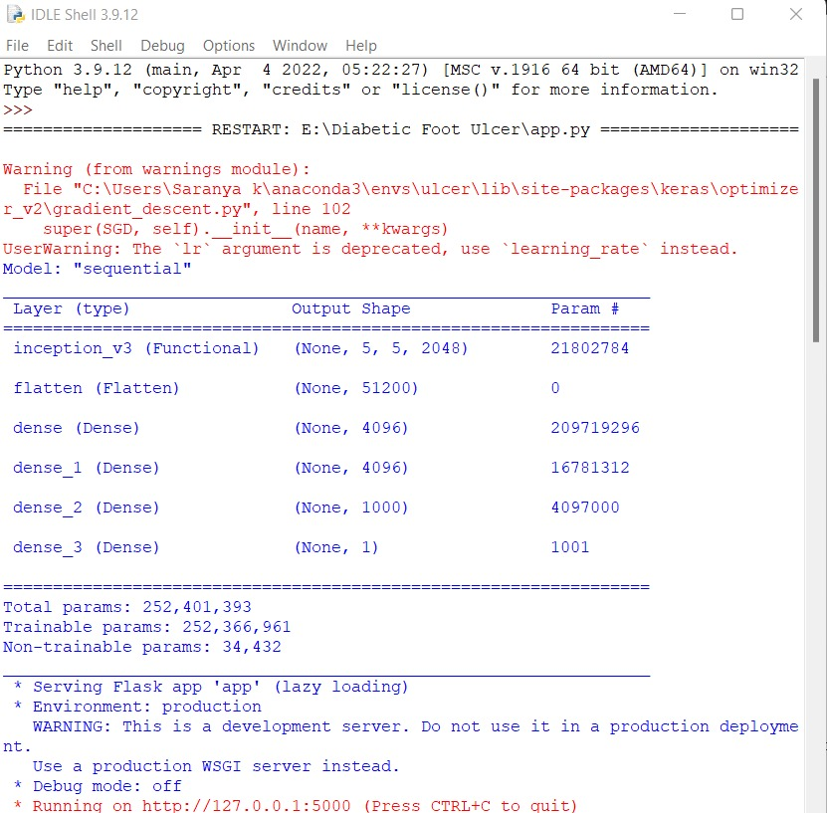
Figure.7.2. Idle Shell

- The home page gets displayed as follows.

Figure.7.3. DFU Home Page

- Choose the image from the Test data to detect the DFU.
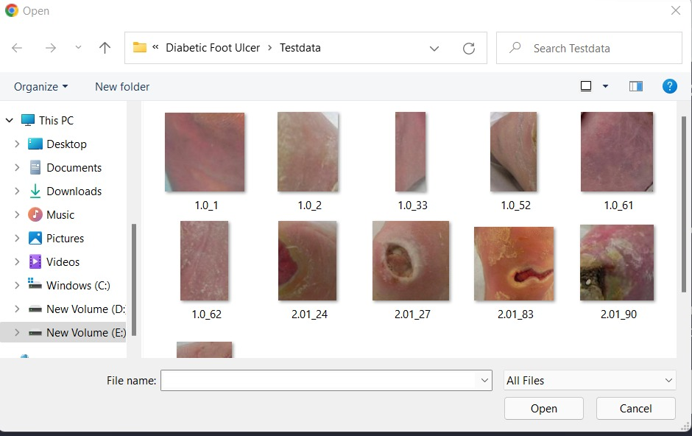

Figure.7.4. Test images

- The image is extracted from the folder and the result of detection is displayed.
- Here the skin is a healthy skin and it is also displayed with the percentage of skin infected.
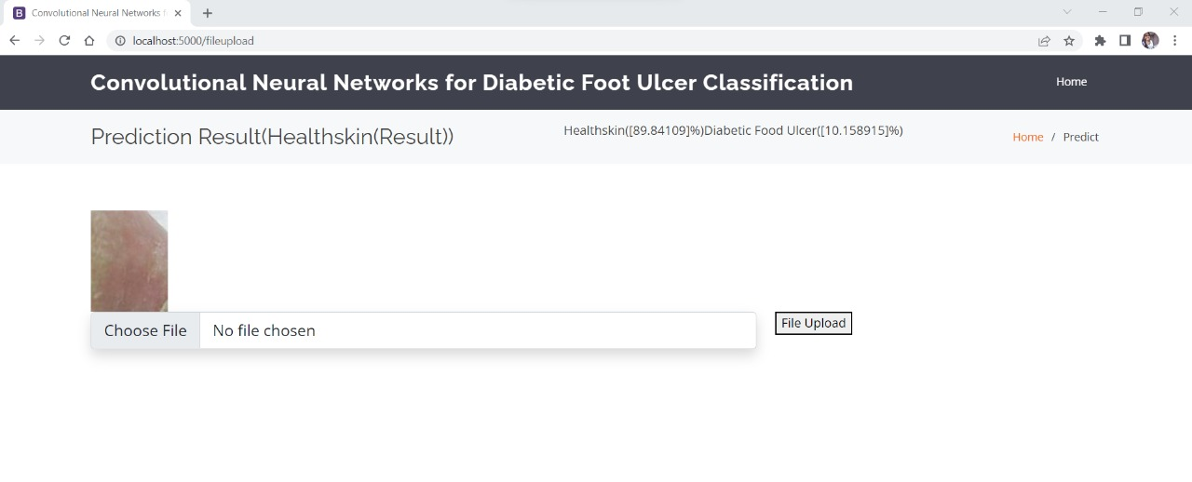
Figure.7.5. Result of DFU Detection (Healthy Skin)

- Here the image is the Diabetic Foot Ulcer skin and it also displays the percentage of skin infected.
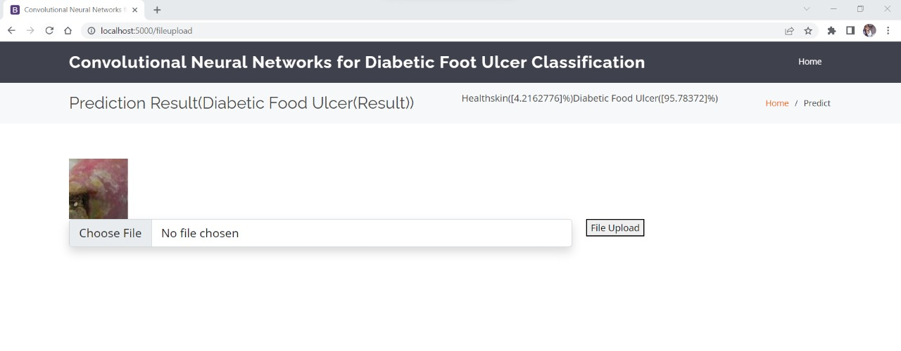

Figure.7.6. Result of DFU Detection (Diabetic Foot Ulcer Skin)

- The accuracy of the system is displayed as follows.
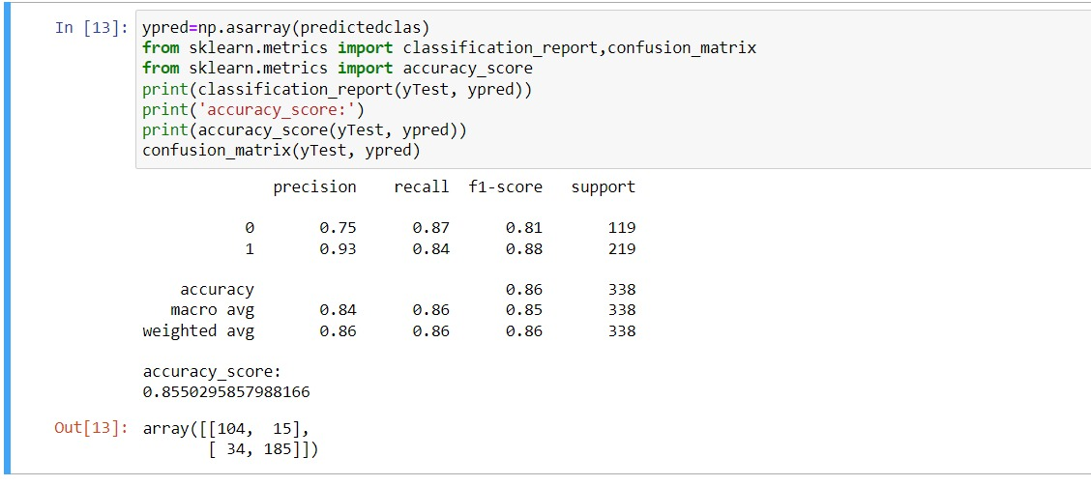

Figure.7.7. Accuracy Calculation

- The files in the Jupyter Notebook is displayed as follows.
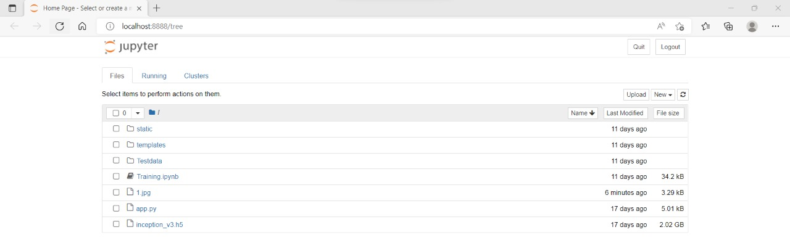

Figure.7.8. Jupyter Notebook Files

- The training code is displayed as follows.
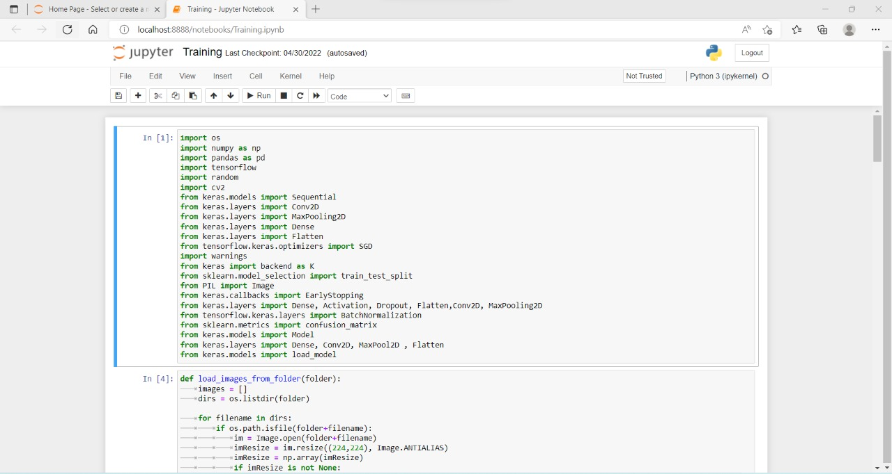

Figure.7.9. Training code

- The output array of the image convolutions is displayed as follows.
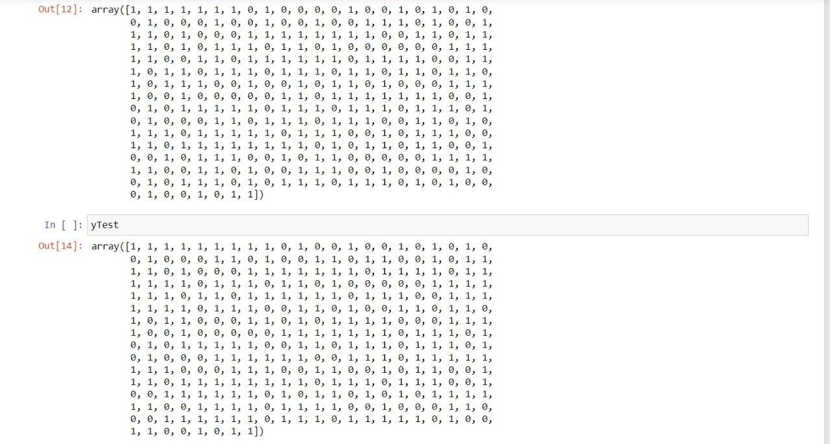
Figure.7.10. Output Array
8. REFERENCE

[1] Matilde Monteiro-Soares, Edward J. Boyko et.al “Diabetic foot ulcer classifications: A critical review” Wiley Online Library 16 March 2020
[2] Mayland Chang and Trung T. Nguyen “Strategy for Treatment of Infected Diabetic Foot Ulcers” 2021 American Chemical Society
[3] Moi Hoon Yap a , Ryo Hachiuma et.al “Deep learning in diabetic foot ulcers detection: A comprehensive evaluation” Computers in Biology and Medicine (2021)
[4] Paola C. Aldana ,Amor Khachemoune et.al “Diabetic Foot Ulcers: Appraising Standard of Care and Reviewing New Trends in Management” American Journal of Clinical Dermatology 17 December 2019.
[5] Danielle Dixon, Michael Edmonds et.al “Managing Diabetic Foot Ulcers: Pharmacotherapy for Wound Healing” Springer Nature Switzerland AG 2020
[6] Dragos Serban, MD, PhD1, Nikolaos Papanas, MD, PhD et.al “Diabetic Retinopathy in Patients With Diabetic Foot Ulcer: A Systematic Review” The International Journal of Lower Extremity Wounds 2020
[7] Morica M. Tran and Melanie N. Haley “Does exercise improve healing of diabetic foot ulcers? A systematic review” Journal of Foot and Ankle Research (2021)
[8] C. E. Hazenberg, J. J. van Netten, S. G. van Baal, and S. A. Bus, “Assessment of signs of foot infection in diabetes patients using photographic foot imaging and infrared thermography,” Diabetes technology & therapeutics, vol. 16, no. 6, pp. 370–377, 2014
[9] P. Foltynski, J. M. Wojcicki, P. Ladyzynski, K. Migalska-Musial, G. Rosinski, J. Krzymien, and W. Karnafel, “Monitoring of diabetic foot syndrome treatment: some new perspectives,” Artificial organs, vol. 35, no. 2, pp. 176–182, 2011
[10] C. Liu, J. J. van Netten, J. G. Van Baal, S. A. Bus, and F. van Der Heijden, “Automatic detection of diabetic foot complications with infrared thermography by asymmetric analysis,” Journal of biomedical optics, vol. 20, no. 2, pp. 026 003–026 003, 2015.
[11] L. Wang, P. C. Pedersen, D. M. Strong, B. Tulu, E. Agu, R. Ignotz, and Q. He, ‘‘An automatic assessment system of diabetic foot ulcers based on wound area determination, color segmentation, and healing score evaluation,’’ J. Diabetes Sci. Technol., vol. 10, no. 2, pp. 421–428, Mar. 2016
[12] D. Coppini, ‘‘New NICE guidelines on diabetic foot disease prevention and management,’’ Practical Diabetes, vol. 32, no. 8, p. 286, 2015
[13] I. Kavakiotis, O. Tsave, A. Salifoglou, N. Maglaveras, I. Vlahavas, and I. Chouvarda, ‘‘Machine learning and data mining methods in diabetes research,’’ Comput. Struct. Biotechnol. J., vol. 15, pp. 104–116, 2017.
[14] Liu, C., van Netten, J. J., Van Baal, J. G., Bus, S. A., and van Der Heijden, F. (2015). Automatic detection of diabetic foot complications with infrared thermography by asymmetric analysis. Journal of biomedical optics, 20(2):026003
[15] L. Wang et al., “Wound image analysis system for diabetics,” Int. Soc. Opt. Photonics, vol. 8669, p. 866924, 2013.
[16] Armstrong DG, Boulton AJ, Bus SA. Diabetic foot ulcers and their recurrence. N Engl J Med. 2017;376(24):2367-2375
[17] Fife CE, Horn SD, Smout RJ, Barrett RS, Thomson B. A predictive model for diabetic foot ulcer outcome: the Wound Healing Index. Adv Wound Care. 2016
[18] R. Brüngel, C.M. Friedrich, DETR and YOLOv5: exploring performance and selftraining for diabetic foot ulcer detection, in: 2021 IEEE 34th International Symposium on Computer-Based Medical Systems (CBMS), IEEE, 2021, pp. 148–153.

